**FOR IMMEDIATE RELEASE**

Jayne Feldman

BRAVE Public Relations

404.233.3993

[jfeldman@emailbrave.com](mailto:jfeldman@emailbrave.com)

**TICKETS NOW ON SALE  
FOR THE PREMIERE ATLANTA ENGAGEMENT**

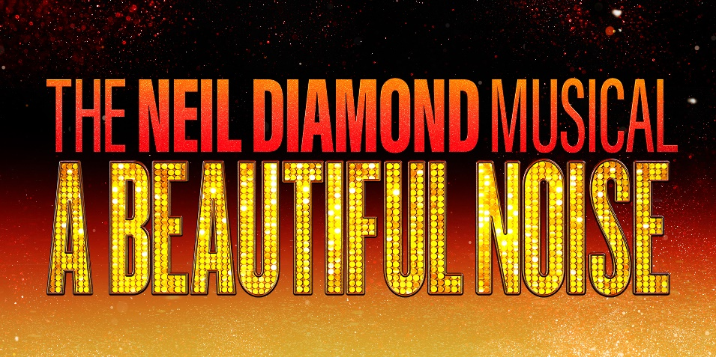

**COMING TO THE FOX THEATRE FROM**

**MARCH 11-16, 2025**

**BROADWAY STAR AND “AMERICAN IDOL” WINNER**

**NICK FRADIANI**

**PLAYS THE TITLE ROLE IN THE NATIONAL TOUR**

**ATLANTA (Jan. 17, 2025)** – Producers **Ken Davenport, Bob Gaudio** and **NETworks Presentations** along with **Regions Bank Broadway in Atlanta** are thrilled to announce that individual tickets for the smash-hit musical, **A BEAUTIFUL NOISE: THE NEIL DIAMOND MUSICAL**, are now on-sale. **BEAUTIFUL NOISE**makes its Atlanta premiere at the Fox Theatre as part of the 2024/2025 Regions Bank Broadway in Atlanta season for a limited one-week engagement March 11-16, 2025. Tickets are available at the Fox Theatre box office at 660 Peachtree Street NE, by visiting [foxtheatre.org/ABeautifulNoise](https://foxtheatre.evenue.net/cgi-bin/ncommerce3/SEGetEventList?xd_co_f=YjIxNTU1NzgtMDE3YS00NmQxLTk4Y2ItMTA3ODBlODUyYWNl&groupCode=ABN&linkID=fta&shopperContext=&caller=&appCode=&_gl=1*189qke6*_gcl_aw*R0NMLjE3MzM3NTk5NzMuQ2p3S0NBaUE2YVc2QmhCcUVpd0E2S3pEYzhLd2hraklMRUFSdzFHcnRuanRDd3VacUhmVTRBS29SOEhiQTFUREI4cm5CQXBpOWVXMEpSb0NERGtRQXZEX0J3RQ..*_gcl_au*NzQzMzY3NDE3LjE3MzQxMDY0NTE.*_ga*Njg4MDc4MzcwLjE2NzEyMDQyMzg.*_ga_WSC66LRLJS*MTczNDU0NzU4Ni44MS4xLjE3MzQ1NTAxNzUuNjAuMC4w*_ga_QHSKR7YDB2*MTczNDU0NzU4Ny4xNzcuMS4xNzM0NTUwMTc1LjYwLjAuMA..&_ga=2.25597565.1532605936.1734547588-688078370.1671204238&_gac=1.259639160.1733759973.CjwKCAiA6aW6BhBqEiwA6KzDc8KwhkjILEARw1GrtnjtCwuZqHfU4AKoR8HbA1TDB8rnBApi9eW0JRoCDDkQAvD_BwE) or by calling 855-285-8499. Group orders of 10 or more may be placed by contacting [sales@foxtheatre.org](mailto:sales@foxtheatre.org).

**A BEAUTIFUL NOISE** will play for a limited one-week engagement in Atlanta from March 11 – 16. The performance schedule is:

Tuesday – Thursday                       7:30 p.m.

Friday                                                        8 p.m.

Saturday                                                      2 p.m., 8 p.m.

Sunday                                                  1 p.m., 6:30 p.m.

Created in collaboration with Neil Diamond himself, **A BEAUTIFUL NOISE** is the uplifting true story of how a kid from Brooklyn became a chart-busting, show-stopping American rock icon. With 120 million albums sold, a catalogue of classics like "America," "Forever in Blue Jeans," and "Sweet Caroline," an induction into the Songwriters and Rock and Roll Halls of Fame, a Grammy® Lifetime Achievement Award, and sold-out concerts around the world that made him bigger than Elvis, Neil Diamond's story was made to shine on Broadway-and head out on the road across America.

“Some of my most thrilling nights have been while I was on tour, bringing my music to audiences across the world,” said Neil Diamond. “Having **A BEAUTIFUL NOISE** go on tour is an honor and I can’t wait for audiences across North America to experience this show. I hope they enjoy it as much as I have.”

**Nick Fradiani** plays ‘Neil Diamond – Then’ in the national tour directly from playing the role on Broadway since October 2023. He won the title of “American Idol” in 2015 and has since released his debut album “Hurricane” in 2016, featuring the hit single “Beautiful Life.” “Past My Past,” Fradiani’s second solo album, was released in 2022. Joining Fradiani are Tony Nominee **Robert Westenberg** (Neil Diamond – Now), **Hannah Jewel Kohn** (Marcia Murphey), **Lisa** **Reneé Pitts** (Doctor), **Michael Accardo** (Bert Berns/ Kieve Diamond), **Tuck Milligan** (Fred Weintraub/ Tommy O'Rourke), **Kate A. Mulligan** (Ellie Greenwich/ Rose Diamond)and **Tiffany Tatreau** (Jaye Posner).

Rounding out the company as “The Noise” are **Cooper Clack**, **Chris Marsh Clark**, **Dennis Dizon** (Swing), **Dale Duko**, **Deirdre Dunkin**, **Rene Mirai** **Guyon** (Swing), **Ginger Hurley, Jer** (Swing), **Spencer Donavan Jones**, **Zoë Maloney** (Swing), **Ellen McGihon**, **Thabitha Moruthane**, **Tasheim Ramsey Pack**, **Jeilani Rhone-Collins**, **Daniela Rodrigo** (Swing), **Alec Michael Ryan** (Swing) and **J’Kobe** **Wallace**.

“THE BIOGRAPHICAL DRAMA IS A HEARTWARMING CELEBRATION OF MR. DIAMOND’S UPLIFTING MUSIC AND INSPIRATIONAL LIFE.” -The Washington Times

Like *Jersey Boys* and *Beautiful: The Carole King Musical* before it, **A BEAUTIFUL NOISE: THE NEIL DIAMOND MUSICAL** is an inspiring, exhilarating, energy-filled musical memoir, that tells the untold true story of how America's greatest hitmaker became a star, set to the songs that defined his career.

Producer Ken Davenport said, “Neil is one of the best live entertainers the world has ever seen. In his fifty-year career, he’s performed for millions of fans around the globe. I couldn’t imagine a more perfect way to honor his legacy than having **A BEAUTIFUL NOISE** touring North America, visiting the same cities where he gave so many people so much joy. Now, after a successful Broadway run, good times never seemed so good as **A BEAUTIFUL NOISE: THE NEIL DIAMOND MUSICAL**, is in Atlanta making its premiere at the Fox Theatre in 2025.”

Producer Bob Gaudio said, “When Neil and I first started talking about making a musical using his music, I knew how daunting that would be. With *Jersey Boys*, I learned how vital it is to have a first-rate creative team making sure everything weaves together. We have that on **A BEAUTIFUL NOISE**—an incisive book that tells Neil’s story honestly, fantastic choreography, one of the best directors on Broadway guiding the entire production, and of course, Neil’s iconic songs.”

**A BEAUTIFUL NOISE: THE NEIL DIAMOND MUSICAL** is directed by Tony Award® winner Michael Mayer (*Spring Awakening, Hedwig and the Angry Inch*), choreographed by Olivier Award winner Steven Hoggett (*Once, Harry Potter and the Cursed Child*), and written by four-time Academy Award nominee Anthony McCarten (*Bohemian Rhapsody, The Two Popes*).

The design team for **A BEAUTIFUL NOISE** features Tony Award winner **David Rockwell** (Scenic Design), Tony Award nominee **Emilio Sosa** (Costume Design), four-time Tony Award winner **Kevin Adams** (Lighting Design), Tony Award winner **Jessica Paz** (Sound Design), and **Luc Verschueren** (Hair and Wig Design). The production has Music Supervision and Arrangements by **Sonny Paladino**, Incidental Music and Dance Music Arrangements by **Brian Usifer**, Vocal Design by **AnnMarie Milazzo**, and Orchestrations by **Bob Gaudio, Sonny Paladino**, and **Brian Usifer**. The team also includes **Jamie Harrison** (Illusion Design), **Kathy Fabian** (Production Properties Supervisor), **Jim Carnahan, CSA** and **Jason Thinger, CSA** (Casting), **Madeline McCluskey** of **Gentry & Associates** (General Management) and **Hector Guivas** of **NETworks Presentations** (Production Management).

The **A BEAUTIFUL NOISE** National Tour Director is **Austin Regan**, Tour Choreographer is **Yasmine Lee**, and Tour Music Director is **James Olmstead**. The **A BEAUTIFUL NOISE** National Tour Stage Management team is led by **Stacy N. Taylor** with **Travis Blackwell** and **Kali Ashurst**. The Company Management team is **Erik Birkeland** and **Heather Moss**.

**A BEAUTFUL NOISE: THE NEIL DIAMOND MUSICAL** has raised $750,000 for the Parkinson’s Foundation. For more information on how you can help, visit [www.abeautifulnoisethemusical.com/partners](http://www.abeautifulnoisethemusical.com/partners).

For more information about the show, visit [www.abeautifulnoisethemusical.com](http://www.abeautifulnoisethemusical.com) and follow along on [Facebook](https://www.facebook.com/ABeautifulNoiseMusical), [Instagram](https://www.instagram.com/ABeautifulNoiseMusical), [X/Twitter](https://x.com/beautifulnoise) and [YouTube](https://www.youtube.com/@abeautifulnoisemusical).

# # #

**A BEAUTIFUL NOISE** production photos are available[**HERE**](https://www.dropbox.com/scl/fo/cezbchmxe5nfap9eievmo/APOKpNtQkaxhCrIONyvKB6o?rlkey=3kq5fg3y8kxqd4fml61bve2g2&st=rgb042kv&dl=0) and b-roll is available[**HERE**](https://www.dropbox.com/scl/fo/l1ugm88epe017oe3tl01q/AArJvjofP3Pgt1L8bqo8HMY?rlkey=ddu0ynpaoxpivee99ikkv3qmd&st=pn3p6ene&dl=0).

**About Regions Bank Broadway in Atlanta**  
The **John Gore Organization** is the leading presenter, distributor, and marketer of Broadway theater worldwide. Under the leadership of 22-time Tony-winning theater producer and owner John Gore, its family of companies includes Broadway Across America, Broadway.com, The Broadway Channel, BroadwayBox.com, Group Sales Box Office and Broadway Brands. The company presents shows in 48 cities across North America as well as on Broadway, Off-Broadway, London’s West End, Japan, and China. It has won Tony Awards in every producing category as well as numerous other Drama League, Drama Desk, and Olivier Awards.  The John Gore Organization is committed to supporting theater access and education programs that introduce Broadway to the next generation of audiences and theater professionals.

**Broadway Across America (BAA)** is part of the John Gore Organization family of companies, which includes Broadway.com, The Broadway Channel, BroadwayBox.com, Group Sales Box Office, and Broadway Brands.  Led by 22-time Tony-winning theater producer John Gore (Owner & CEO), BAA is the foremost presenter of first-class touring productions in North America, operating in over 45 markets with over 475,000 subscribers. Presentations include Disney’s *The Lion King*, *Wicked*, *The Book of Mormon*, and *Hamilton*. Current productions include *&Juliet*, *Hadestown*, *Hamilton*, *Hell’s Kitchen*, *MJ: The Musical*, *Moulin Rouge! The Musical*, *The Outsiders* and *Stereophonic*.